DEVOPS NOTES BATCH-8

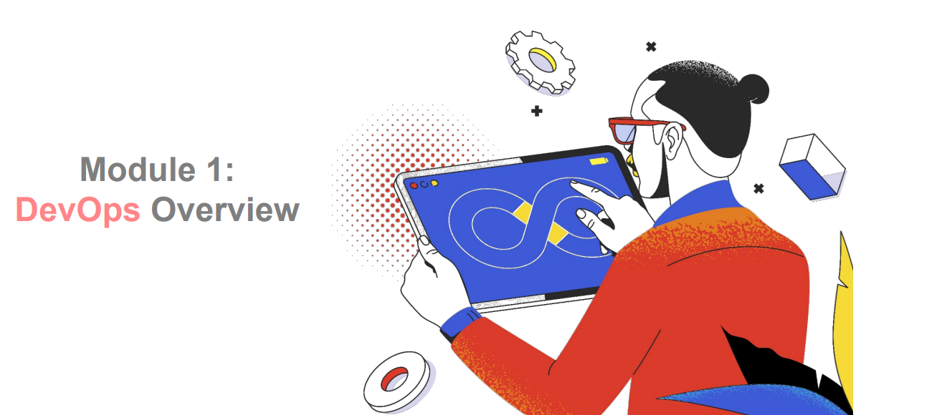



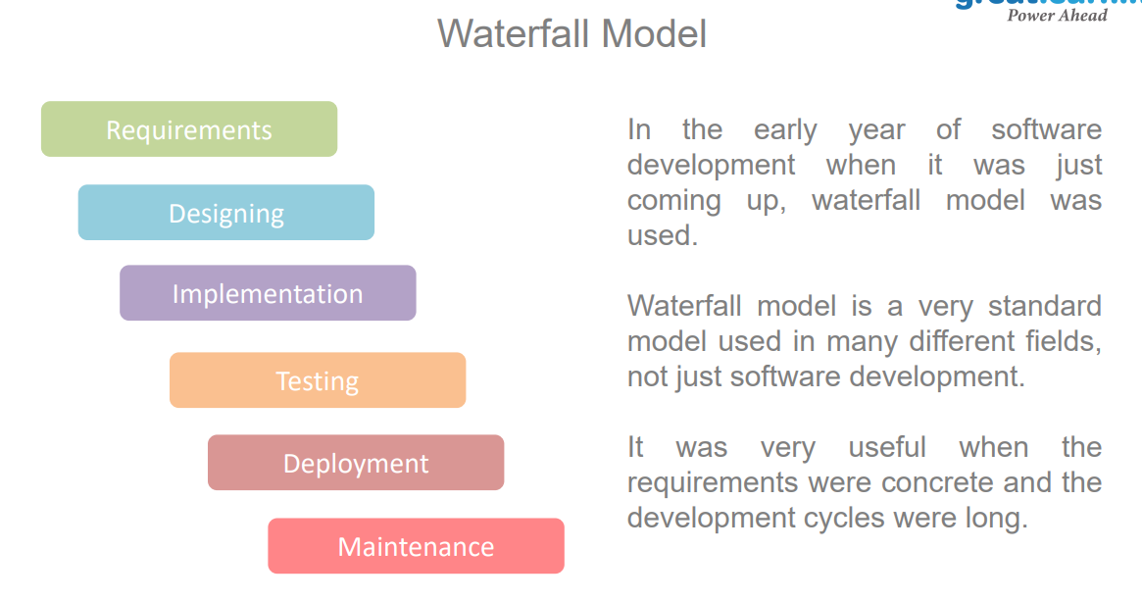

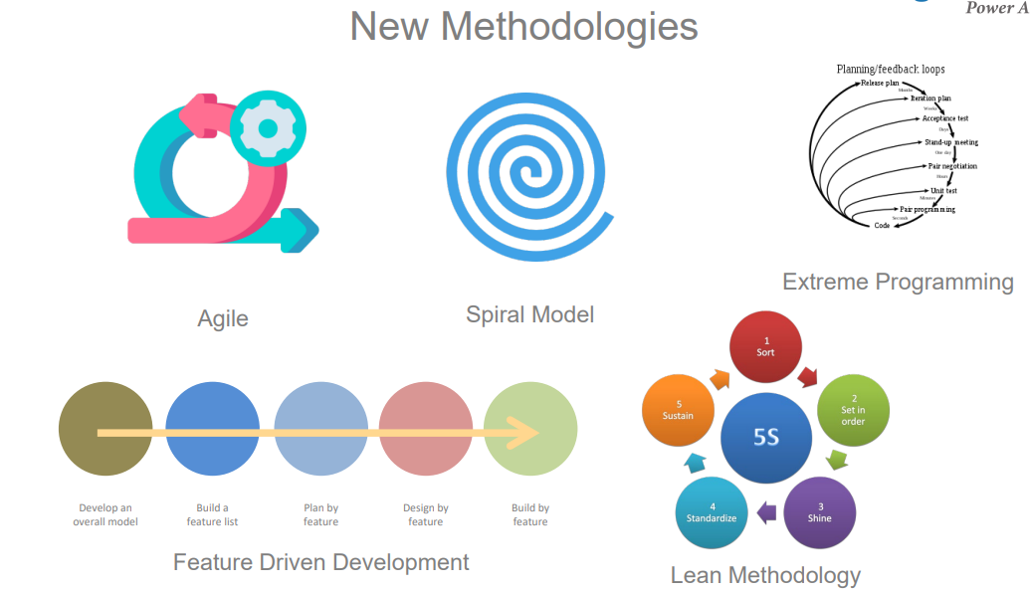

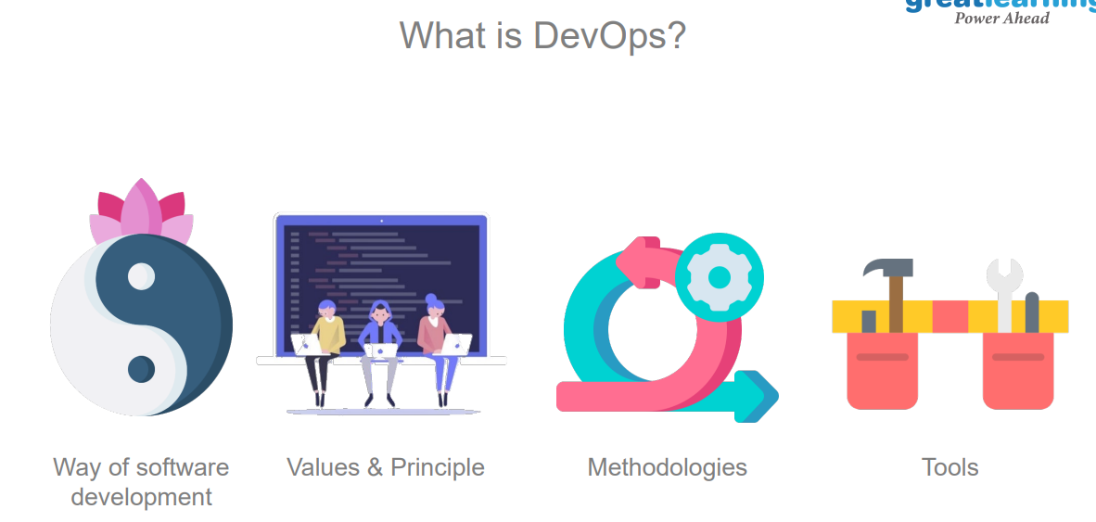
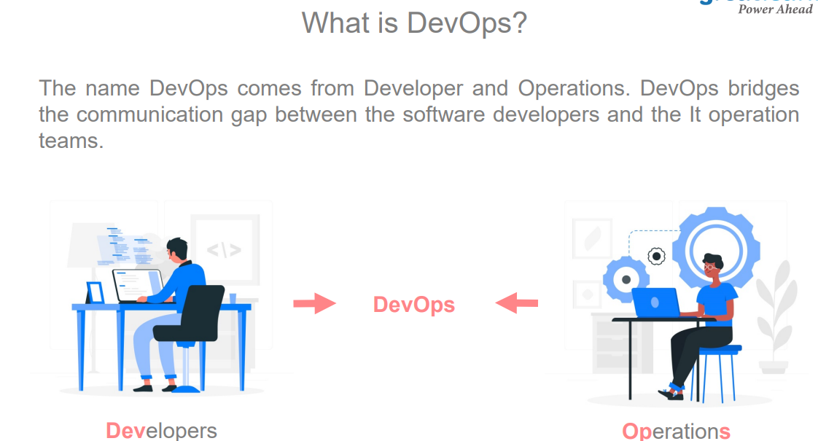

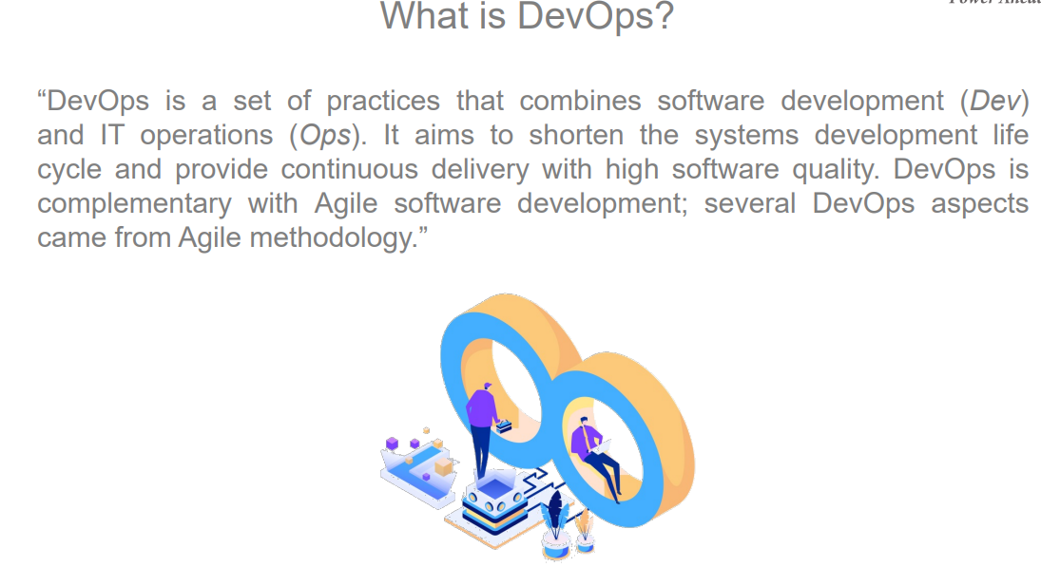
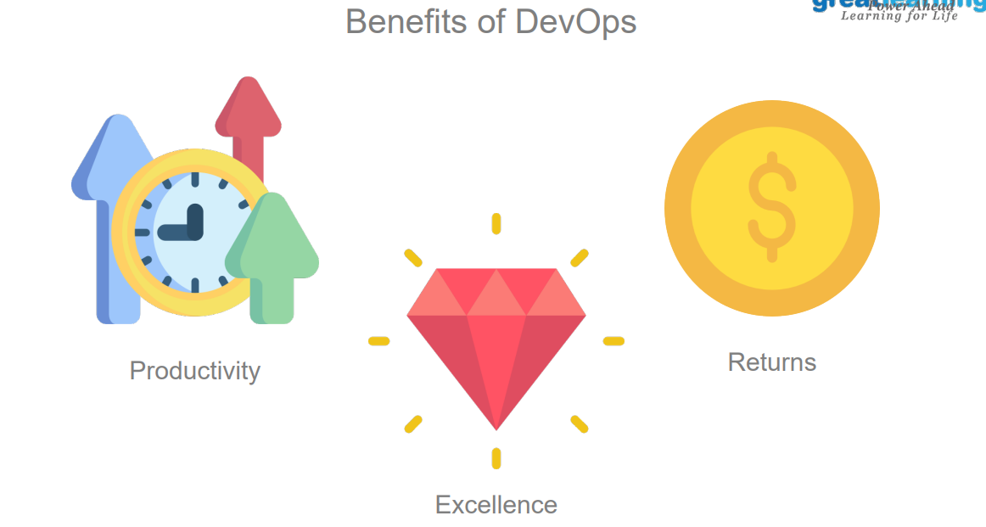

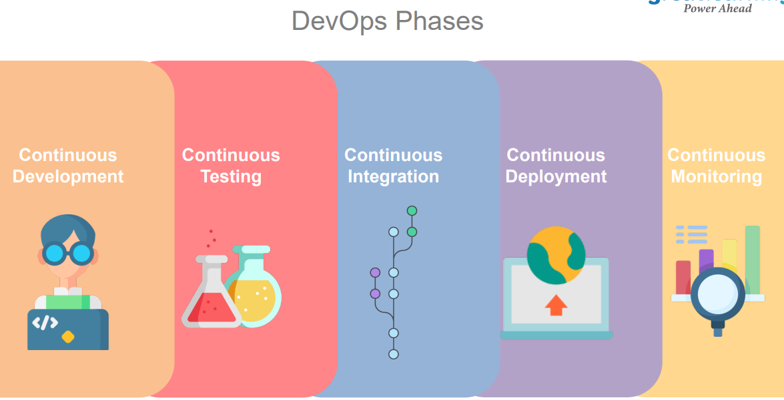

Basic DevOps Tools & Linux Commands:

- SCM (Source Code mangament)
Tools : Git, GitHub, SVN, Bitbucket etc…
- Build (Compile & Package)
Tools : Ant, Maven, Gradle, Fastlane ….
- CI/CD (Continuous integration & Continuous Deployment & Delivery)
Tools: Jenkins, Bamboo, Circleci, Team city etc.…
- Code Quality (Validate Code syntax & Rules)
Tools: SonarQube
- Artifactory (Storing Artifacts Backp)
Tools : jfrog, Nexus
- Deployment (Deployment & Configuration management)
Tools: Ansible, Chef, Saltstack, Puppet, Appcenter etc.
- Cloud
Providers: AWS, GCP, Azure etc.
- Docker (Containerization tool)
- Kubernetes (Orchestration tool)
- Terraform (Infrastructure management tool)
- Linux Commands * basic Networking commands
- XML, JSON, YAML, SHELL etc.

Day1
Version Control Git:

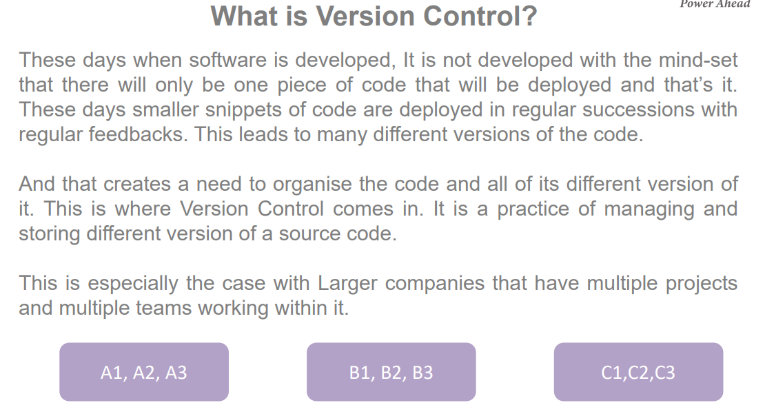

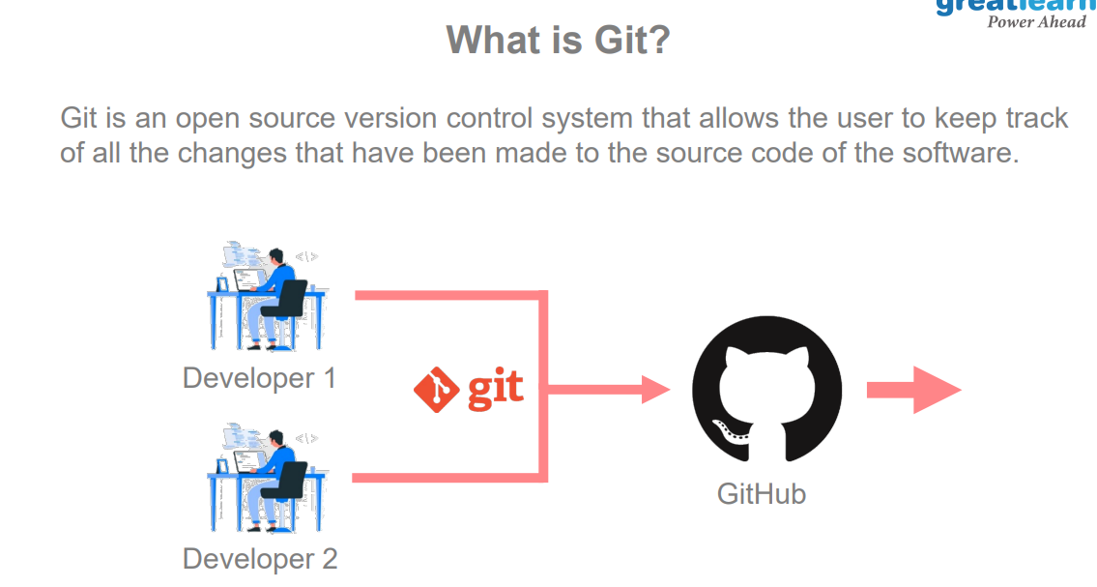

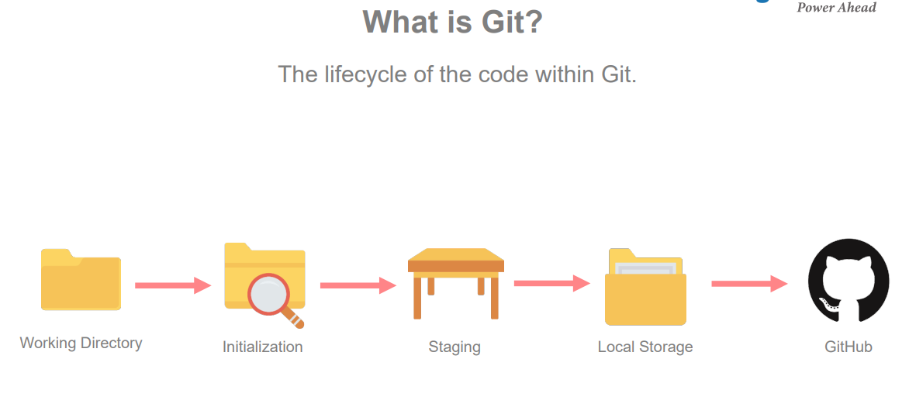

Basic Linux Commands:

- pwd = present working directory (folder)
- mkdir = make directory (create folder) (EX: mkdir demo)
- touch = create the files (EX: touch filename)
- cd = change directory (Ex: cd movies)
- ls = list of files
- ls -a = list of hidden files
- ls -ll = long list of all files (ll = longlist)
- cp source destination (EX: cp abcd.txt 123.txt)
- mv source destination (By using this we can rename and move the files)
Ex: mv abcd.txt myfile.txt or. mv abcd.txt c/user/username/foldername
- rm filename (we can delete the file)
- rm -rf foldername (we can delete files & Folder forcefully)
- ipconfig = Windows (to find ip address)
- ifconfig = linux & Mac
- ipaddr = find the ipaddress
- ping ipaddress (to check the server is up or down)
- chmod (by using this we can give access permissions to the files & Folders)
- grep = filter the process ids
- find = find the listed required files
- top = to see the running process occupied space
- kill = to stop the process
- ps -ef = present status of running applications
- wget. : by using this we can download packages from internet.
- Curl : by using this we can download & Upload packages to internet.
- how to edit files and add the content in linux:
create a file = touch filename
vi filename
I = insert
Write content
Press esc
:wq! = save the data & quit.
25: . (dot) = present place or directory or folder
- cd .. = to go one step back
- Cd ../../.. = to three steps back
- Df -h = too see the diskspace
- Cat : To read the contenet in following file.

Git bash Link : Git - Downloads (git-scm.com) -window 10 (standalone)
Git - Downloads (git-scm.com) -windows 11
Source Code Management Git Hub:
GitHub is possibly the most famous and widely used open-source platform amongst developers. Launched by Linus Torvalds in 2005, Git is a version control software and collaboration platform that initially only supported Linus kernel.

Git is used as a storage space for the content which is programming code written by different programmers, designers, and developers. It isn’t necessarily written by a single developer, more often than multiple developers are working on real-life projects. Git eliminates any conflicts and facilitates coordination between developers.
Git is basically a code-hosting platform where there is uninterrupted accessibility to open-source programming frameworks, libraries, and languages. It hosts the largest community of tech developers in the world.

Git also allows users to store the previous iterations of code in a historical form which can be revisited and reviewed as required. It consists of a branch system to help developers work independently on separate tasks. It also allows you to host a website from your repository.
GitHub’s large base is used to deduce useful insights on programming languages and frameworks. For instance, as per its annual The State of the Octoverse report, the most popular GitHub project of 2019 was the open-source Microsoft/vscode with 19,100 contributors.
In this article, we will take a look at the installation process of Git, and find out how to use GitHub. So let’s get started!

Repositories : (Storage )
Online repo or central repo or remote repo
Local repository

Pull or Clone = taking code from online repo to local repo (laptop)
Do the required changes in code and do the commit
Push to online repository

Tools : Git,Github, Bitbucket etc….

Gitbash (localy install). ---------------- Github (online repo)

Steps:
Create Github account in online?
Create repository in github?
Install git bash in local (laptop)?
Clone the code from github repository to local?
Do the required changes and add commit?
Push the latest code chabges to github?

Create Github account in online?
Go to google use the below link https://github.com/join?source=login
Username Emailid Password Verify the account create account select student learn to code interested in DevOps create account verify email address login into github account.
Create repository repo name description public initialize with readme file create reposit
Repo Creation: Select New repo -> Give name according to you reqirements ->Description is optional -> select private -> select add read me file and create.

Git Developer Actions:
To integrate git with github:
Git config -- global user.name “Here your github_id”
Git config -- global user.mail “Here your github_emailid”
If you want to clone the repository:
Git clone “URL- sshkey”
If you want to the copy the from one location to github repo
Cp <source name > <reponame>

Then change directory to githubrepo
Cd <reponame>

Once it is done you need to perform some github actions:
Git add .
Git status
Git commit -m “commit message”
git push

Git branching strategy:

1.To check branch : git branch
2.To create branch : git branch <branch name>
3.To add branch to repository: git remote add <branch name> <repositoty url>
4.To push branch into repository : git push <branchname> -> To push the branch into repository firstly checkout to the branch which you are pushing.
5.To enter into particular branch : git checkout <branch name>
6. To Push any file to particular branch : git push --set-upstream origin <branch name>.

git branch
git branch <branchname>
git checkout <branchname>
git remote add <branchname> git@github.com:Azadshaik117/azad1.git
git push <branchname>
git branch -d <branchname>

Maven:
What Is a Build Tool?
A build tool is essential for the process of building, as these are the tools that automate the process of creating applications from the source code. The build tool compiles and packages the code into an executable form.
A build tool does the following tasks:
- Generates source code
- Generates documentation from the source code
- Compiles source code
- Packages the compiled codes into JAR files
- Installs the packaged code in the local repository, server, or central repository
Why we need maven:
Maven is a software project management build tool based on Project Object Model (POM). The tool is typically used for Java-based projects. Every Java project requires certain dependencies, which are automatically downloaded when running a Maven build. This simplifies everyday tasks for Java developers and helps them with their projects.
Maven helps retrieve the correct JAR files for each project, as there may be different versions of separate packages. If you want to download dependencies, you no longer need to visit each software's official website. It can be quickly done now by visiting "mvnrepository.com."
Ec2-Launch: Linux :
Step1:
Go to services Ec2 launch instance select free-tier LINUX instance select instance type configure instance details add storage select security group add rule select all traffic here we can choose anywhere option add storage add tags download keypair launch view instance.
Note: after few minutes we can able to see our instance and give the required name.

Step2: How to connect instance.
By using git bash, putty and other third-party tools we can use to connect the Ec2 instance.
Select required instance connect select SSH client goto pem download location run the below command chmod 400 class instance.pem copy example and use the command to connect the instance now we are connected.
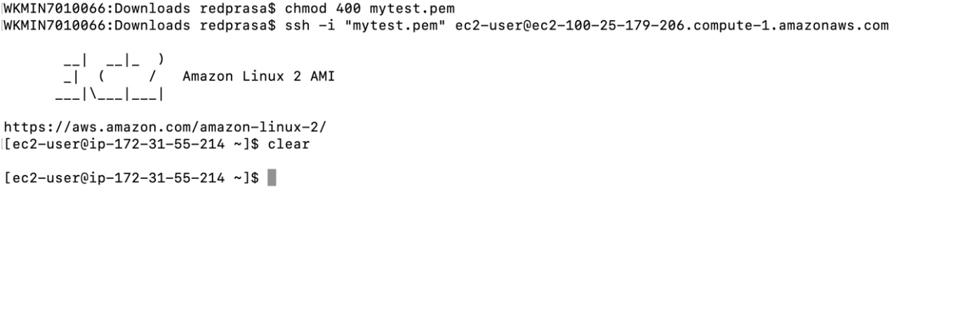
- Connect to instance
- perform the actions in root user -> sudo su
- update the instance -> yum update -y
- To list java -> yum list java*
- To install java -> yum install java-1.8.0-openjdk
- To check the version -> java -version
- Then set up the java path for that you need to run the command -> vim /etc/profile
- export JAVA_HOME=/usr/lib/jvm/java-1.8.0-openjdk-1.8.0.342.b07-1.amzn2.0.1.x86_64
- export PATH=$JAVA_HOME/bin:$PATH
- export MAVEN_HOME=/usr/share/maven
- 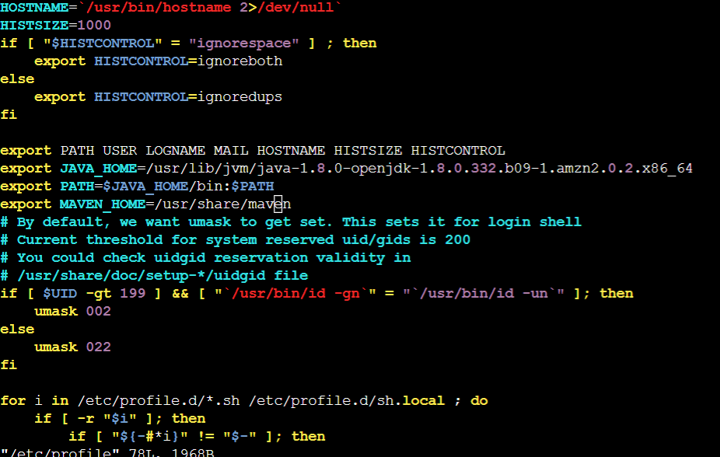
- To load the path run the command -> source /etc/profile
- To check the path of java -> echo $JAVA_HOME
- To list maven -> yum list maven*
- To install maven -> yum install maven -y
- Then set up the java path for that you need to run the command -> vim /etc/profile
- To load the path run the command -> source /etc/profile
- To check the path of maven -> echo $MAVEN_HOME

How to generate pom.xml file :

Firstly we need to give command : mvn archetype:generate

Next we need to give following inputs:
group id: project.com
artifact id: com.project
snapshot: project1.0
Package: war
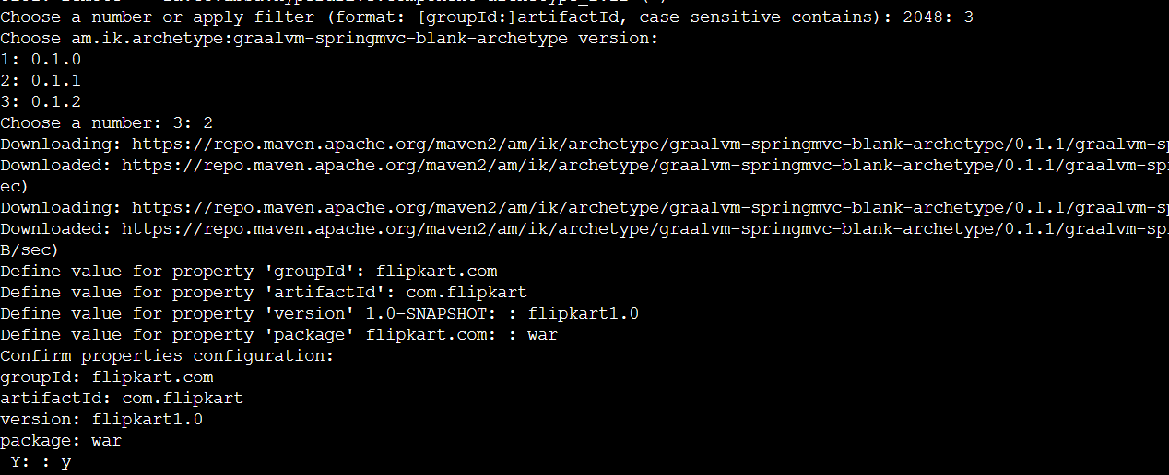
Jenkins Installation:
To install in ubuntu machine follow the link: https://phoenixnap.com/kb/install-jenkins-ubuntu

To install in amazon ec2 instance: https://www.jenkins.io/doc/tutorials/tutorial-for-installing-jenkins-on-AWS/
- Once Jenkins is up and running go to google and search for localhost:8080 go to the below user location and copy the password sudo cat /var/lib/jenkins/secrets/initialAdminPassword
) Continue install sugguested plugins UN =admin Password = admin Confirm-password = admin full name = admin - Email: smjaveed@gmail.com Save & Continue Save & Finish Start using Jenkins.
Install plugins:
Create user account :
Configure tools:
Credentials:
Manage jenkins = 1. Configure systems
2.Global tool configurations
3. Manage Plugins
4.Manage credentials
5.Manage Users
6.Manage nodes
7.system properties etc…..

Job Types:
1. Freestyle job
2.Maven Job
3. Multi job
4. Pipeline job..

How to map jenkins portnumber: java -jar jenkins.war --httpPort=8081
How to install Plugins:
New-Day:

How to install Plugins: By installing this we can get new features

Go to Jenkins Manage Jenkins manage plugins choose available search for plugin select the plugins install without restart or install after restart.
Ex: git , maven integration, gradle, sonar, artifactory,docker, job config history etc…

How to configure Java and Maven:
- To Set environment Varibles:
- Dashboard-> go to manage Jenkins -> global tool configuration -> select which credentials you want to set for java select jdk Name: JAVA_HOME AND SET PATH
- Then apply and save.
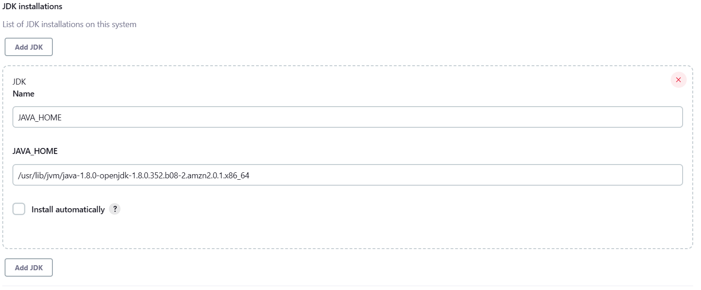

Create Freestyle Job:
Go Jenkins select New item give job name select freestyle job ok.

Go to Job Configure:
Add description add parameters use git SCm to clone the code add URL link add credentials add branch names if required enable the cron tabs Add Execute Shell & save job.

- Create Maven Job: Firstly go to dashboard - > Select new item -> give the name to job For ex: (Mvn job)->Select Maven job -> go to source code management -> select git -> paste your github URl-> Then go to mvn goals – execute maven commands. -> Save and apply ->Trigger build now and for output click consol output and watch logs.

Multi configuration Project:
: Firstly go to dashboard - > Select new item -> give the name to job For ex: (Multi job)->Select multi configuration project -> go to source code management -> select git -> paste your multiple github URl -> Save and apply ->Trigger build now and for output click console output and watch logs

Pipeline Job:
pipeline {
agent any

tools {
maven "MAVEN_HOME"
}
stages {
stage('clone') {
steps {
git credentialsId: 'github_credentials', url: 'https://github.com/Hasnainkhan76/game-of-life.git'
}
}
stage('clean') {
steps{
sh 'mvn clean'
}
}
stage('compile') {
steps{
sh 'mvn compile'
}
}
stage('test') {
steps{
sh 'mvn test'
}
}

stage('build') {
steps{
sh 'mvn package'
}
}
}
}

s

Auto Trigger the job using webhooks:

Firstly go to Jenkins select Jenkins job configure everything asusually but enable the github hook trigger for scm.

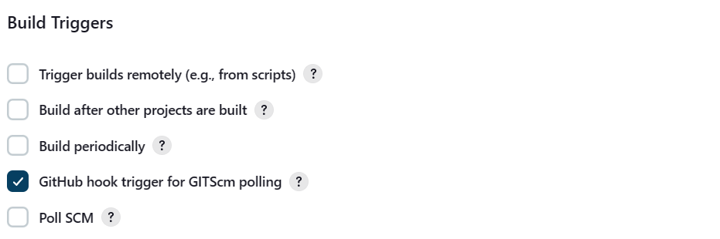

Then go to Github and select Repository and then settings and select webhook then add webhook and configure the details as below.

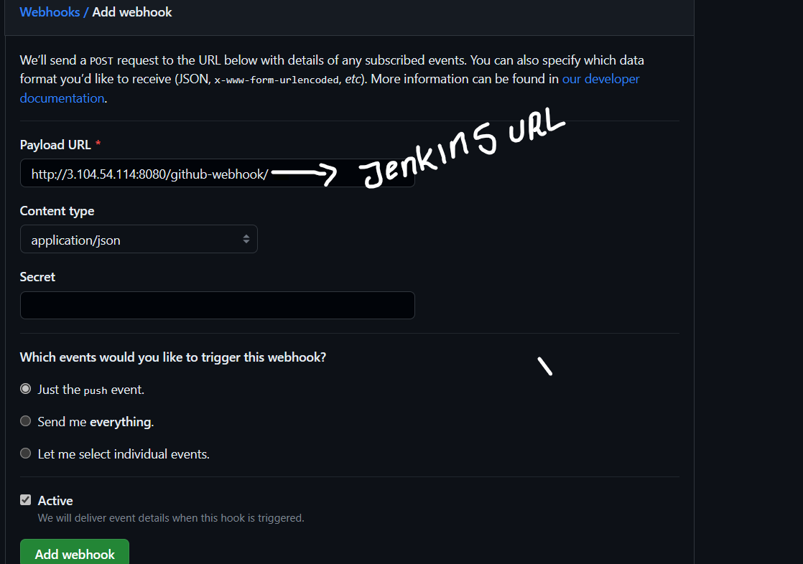
Once it is done make changes to repository and test it.
CronTabs:
“Poll SCM” polls the SCM periodically for checking if any changes/ new commits were made and shall build the project if any new commits were pushed since the last build, whereas the “build” shall build the project periodically irrespective to whether or not any changes were made.

Poll scm will helps to trigger the builds in timely manner if any commits in github repo.

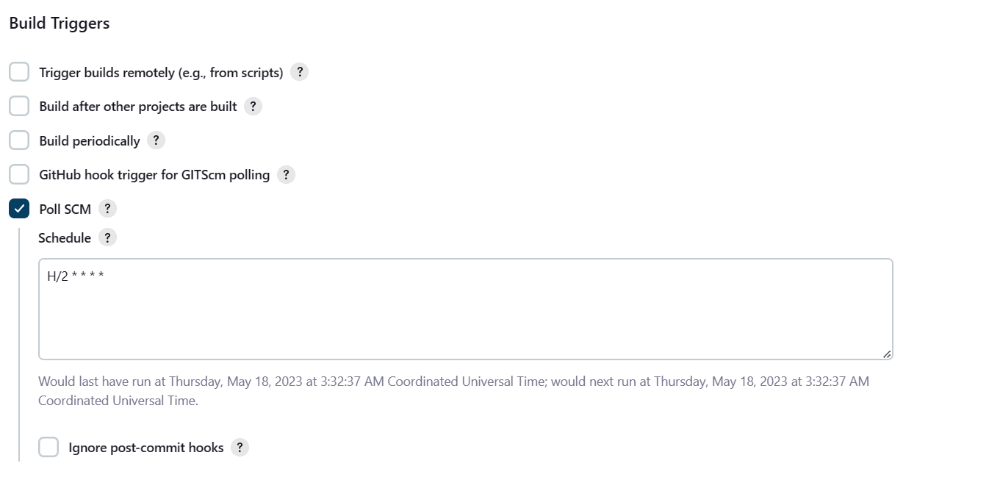

build periodically is different it will build the code without any commits according to its scheduled timings.

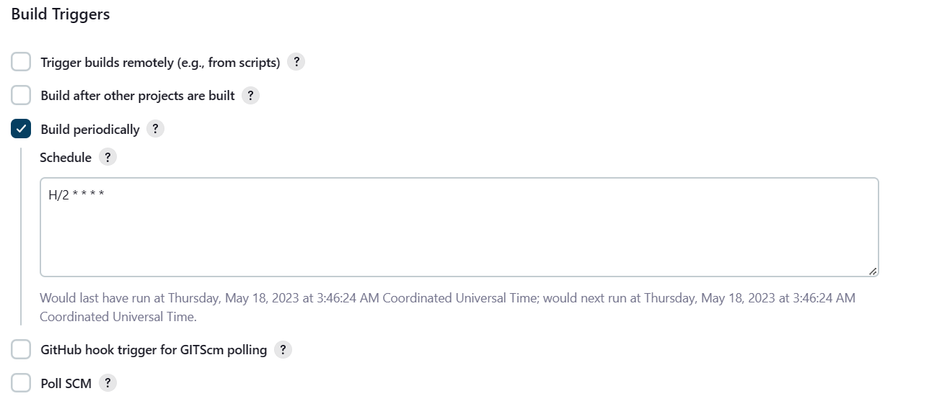

Sonarqube setup:
Refer document: How to install and configure Sonarqube on CentOS 7 step by step guide | Tech Rider Admin's Diary-A Complete CentOS Linux,CCNA,MySQL,MariaDB,Docker Tutorial Guide
- Pre-requisites : Launch T2 medium with 4gb storage -> should install java and maven and set up the path in instance .
- Steps: Firstly select instance with t2 medium and enabling portnumber 9000 then launch and connect and perform the actions on root user (sudo -su)
- Then check weather java is installed or not by cmd: java -version.
- root@localhost ~]# yum install java-1.8.0-openjdk –y

- After installing java we need to verify the java version using the below command.
- [root@localhost ~]# java -version
- openjdk version "1.8.0_191"
- OpenJDK Runtime Environment (build 1.8.0_191-b12)
- OpenJDK 64-Bit Server VM (build 25.191-b12, mixed mode)

- Then we download the sonarqube package on /opt directory using the below command.
- [root@localhost ~]# cd /opt
- # wget https://binaries.sonarsource.com/Distribution/sonarqube/sonarqube-6.4.zip
- # check ls
- Unzip the downloaded file and rename the folder using the below command.
[root@localhost opt]#unzip sonarqube-6.4.zip
- [root@localhost opt]#mv sonarqube-6.4 sonarqube
- Start the sonarqube service
- To start sonarqube service we need to go “/opt/sonarqube/bin/linux-x86-64” directory and execute the below command.
- [root@localhost bin]#./sonar.sh start

- #To check the status we need to run the command
- [root@localhost bin]#./sonar.sh status

- Then to access the sonarqube go to browser paste : instancepublicip:9000
- Then username password by default is : admin ,admin.

Sonarqube integration with jenkins:

- Firstly we need to go to sonarqube there we need to generate the token
- Steps: 1 go to sonarqube portal 2 here go to administration 3.select security
- 4: in that we will get option update token -> here select generate token-> give name and generate token.

- Next step: go to manage jenkin ->go to manage plugins -> go to available search for sonar_scanner plugin and install.

- Next step: go to manage Jenkins-> go to configure system -> here go to sonar quality gate-> here add credential -> username:sonar_scanner serverurl:ipaddress:portnumber -> add token which we generated in sonar qube previously ->apply and save.

- Next step: go to manage Jenkins-> go to global tool configuration ->seclect sonar scanner-> add name: Sonar_scanner then select install automatically then save and
Apply.

pipeline {
agent any

tools {
maven "MAVEN_HOME"
}
stages {
stage('clone') {
steps {
git credentialsId: 'github_credentials', url: 'https://github.com/Dpranathi99/game-of-life.git'
}
}
stage('clean') {
steps{
sh 'mvn clean'
}
}
stage('compile') {
steps{
sh 'mvn compile'
}
}
stage('test') {
steps{
sh 'mvn test'
}
}

stage('build') {
steps{
sh 'mvn package'
}
}

stage('sonar_scanner') {
steps{
sh 'mvn sonar:sonar'
}
}

}
}

Overview
While running an analysis, SonarQube raises an issue every time a piece of code breaks a coding rule. The set of coding rules are defined by the associated quality profile for each language in the project.

Issue types:
There are three types of issues:

Bug: A coding mistake that can lead to an error or unexpected behavior at runtime.
Vulnerability: A point in your code that's open to attack.
Code Smell: A maintainability issue that makes your code confusing and difficult to maintain.
Issue severity
Each issue has one of five severities:

BLOCKER: Bug with a high probability to impact the behavior of the application in production. For example, a memory leak, or an unclosed JDBC connection are BLOCKERs that must be fixed immediately.
CRITICAL: Either a bug with a low probability to impact the behavior of the application in production or an issue that represents a security flaw. An empty catch block or SQL injection would be a CRITICAL issue. The code must be reviewed immediately.
MAJOR: A quality flaw that can highly impact the developer's productivity. An uncovered piece of code, duplicated blocks, or unused parameters are examples of MAJOR issues.
MINOR: A quality flaw that can slightly impact the developer's productivity. For example, lines should not be too long, and "switch" statements should have at least 3 cases, are both be considered MINOR issues.
INFO: Neither a bug nor a quality flaw, just a finding.

  - How to Provide User access:
  - Administration Security Users Create User UN Full-Name Email-id Password Create.
  - How to Modify User access: select user groups enable permissions Done.
  - How to reset user Password User settings change password.
  - How Create API-Token & Reset your Current User Password:
  - Go to User account Security Change Password.
  - Go to User account Security Give Api Token Key Name Generate Api Token.

  - How to Create Quality-Gates:
  - By using this we can pass the Conditions based on issues, if the qulitygate is not passed the condition then Jenkins build will be break or stop.
  - Select QualityGates create qualitygate- name create add conditions.
  - 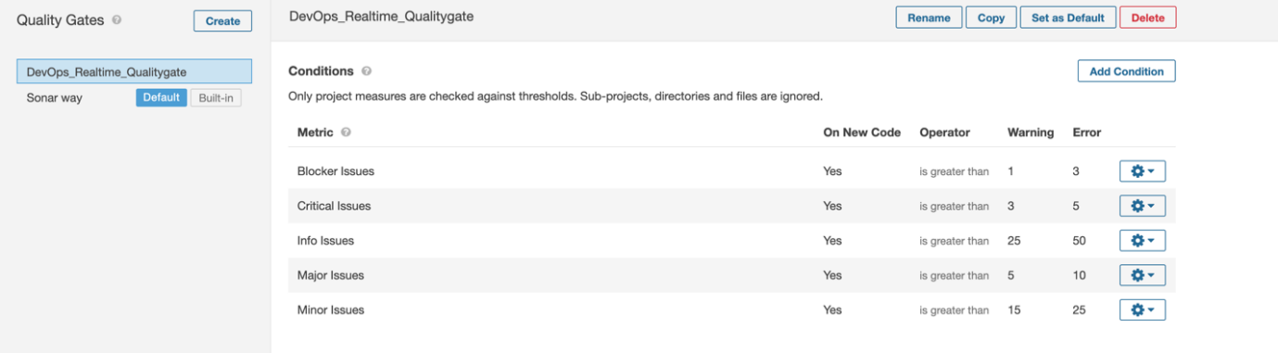

- *** How to create projects & Assign the Qualitygates and qulity profies & Check the Code Quality Errors: ***
- How to create Project: Administration Projects Management create new project Project Name Project Key Create.
- How to assign the Quality gates and profiles to project:
- Select Project Choose project administration Select quality gate or Quality profile Choose required quality gate or Profile it will update automatically.
- How to find project Issue & Types:
- Choose required project project wise issues Seviarity here we can see the Blocker, Critical, Major, Minor and Info issues with Developers name also.

JFrog Installation:

1.Login as a root user and perform actions.
sudo su
2. Install Java version 1.8.0
yum install java-1.8* -y
3. download the jfrog setup in opt directory
cd/opt
4. To install use the url :
wget https://jfrog.bintray.com/artifactory/jfrog-artifactory-oss-6.9.6.zip
5. Unzip the package :
unzip jfrog-artifactory-oss-6.9.6.zip
6. Go inside the directory:
cd artifactory-oss-6.9.6/bin
7.Start the jfrog server:
./artifactory.sh start
8.Then start the jfrog server
http://<PUBLIC_IP_Address>:8081
9.Username: admin
Password: Password

Jfrog Script:
pipeline {
agent any

tools {
maven "MAVEN_HOME"
}
stages {
stage('clone') {
steps {
git credentialsId: 'git_credentials', url: 'https://github.com/Hasnainkhan76/game-of-life.git'
}
}
stage('build') {
steps{
sh 'mvn package'
}
}
stage('sonar_scanner') {
steps{
sh 'mvn sonar:sonar'
}
}
stage('jfrog') {
steps{
sh "curl -u admin:Password -T /var/lib/jenkins/workspace/pipeline-setup/gameoflife-web/target/gameoflife.war 'http://13.231.130.168:8081/artifactory/example-repo-local/'"
}
}
}

INSTALL TOMCAT ON AMI2 INSTANES
- first we need to install java if its new instance if alreay installed not required to install.
$ sudo yum install java-1.8.0 -y
- install tomcat
$ sudo yum install tomcat -y
$ sudo yum install tomcat-webapps tomcat-docs-webapp tomcat-admin-webapps -y
- goto tomcat installation directory i.e $ cd /etc/tomcat/ for change any configuration. For ex need to be configure port and users and roles. if the file is ready only mode open the file with sudo permissions.
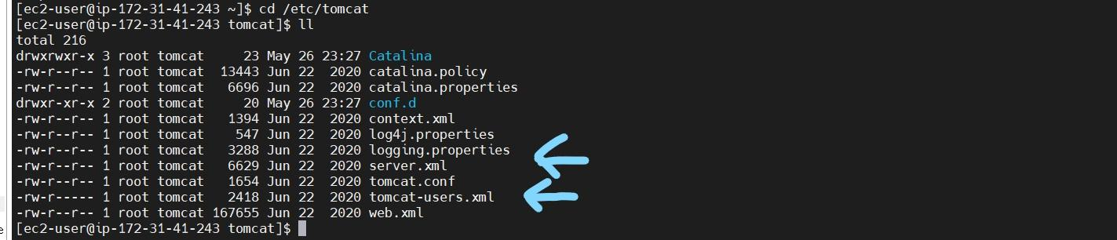

- Now I want to change default port I.e 8080 to 8181. Because my Jenkins also running on same port. If both are same port the server won’t be start its trough the error address already bind exception
- Open the server.xml file under /etc/tomcat/server.xml file and and chage the port and save it.
$ sudo vi server.xml
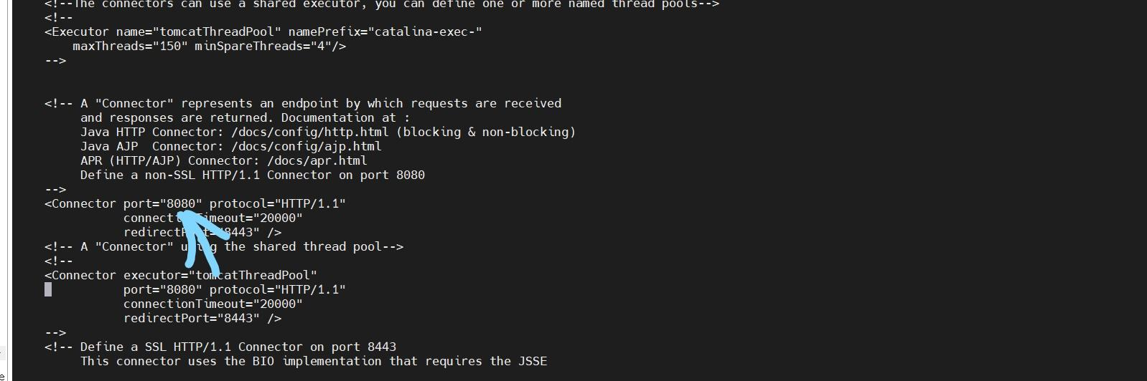
- Now I want add tomcat webui username and password and roles . Open the tomcatusers.xml file and edit and save it.. /etc/tomcat/tomcat-users.xml. add below content under <tomcat-users> tag..
$ sudo vi tomcat-users.xml
https://github.com/fabric8io-images/tomcat/blob/master/images/7/tomcat-users.xml
<tomcat-users>
<role rolename="admin"/>
<role rolename="admin-gui"/>
<role rolename="admin-script"/>
<role rolename="manager"/>
<role rolename="manager-gui"/>
<role rolename="manager-script"/>
<role rolename="manager-jmx"/>
<role rolename="manager-status"/>

<user name="admin" password="admin" roles="admin,manager,admin-gui,admin-
script,manager-gui,manager-script,manager-jmx,manager-status" />

</tomcat-users>
- Paste it in the below location
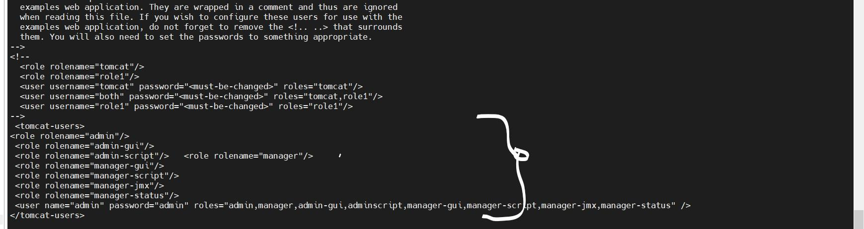
- Start the tomcat server and check the server
$ sudo service tomcat start

$ sudo service tomcat status
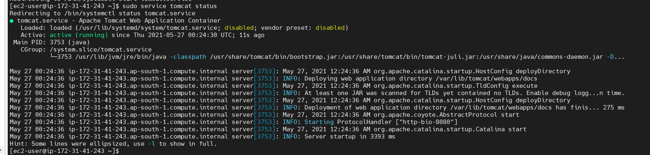
$ sudo systemctl enable tomcat
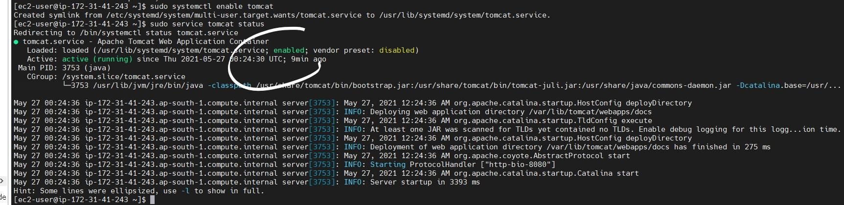
- Give the port:8080 inbound & outbound rule in security group .
- Access the browser DNSip:8181

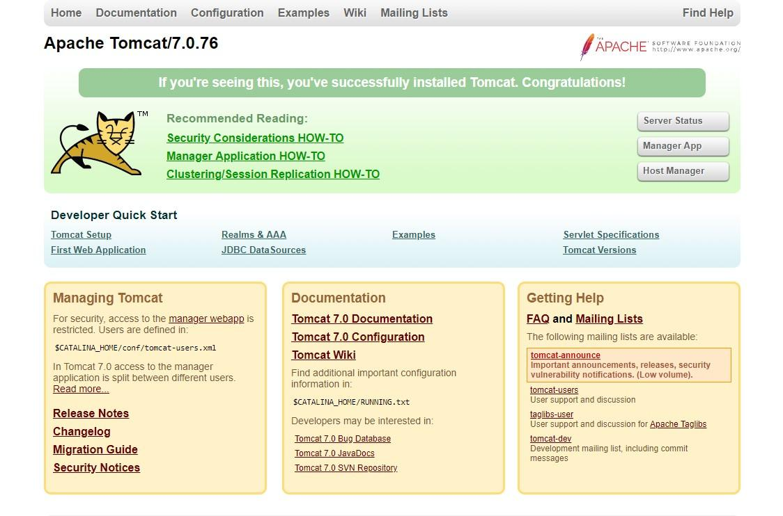

NOTE;- some times, if it fails, won't log in to the manager app then clear the history and reconnect the browsers.

NOTE;- some times, if it fails, won't log in to the manager app then clear the history and reconnect the browsers.

Tomcat deployment Script:

pipeline {
agent any

tools {
maven "MAVEN_HOME"
}
stages {
stage('clone') {
steps {
git credentialsId: 'git_credentials', url: 'https://github.com/Hasnainkhan76/game-of-life.git'
}
}
stage('build') {
steps{
sh 'mvn package'
}
}
stage('sonar_scanner') {
steps{
sh 'mvn sonar:sonar'
}
}
stage('jfrog') {
steps{
sh "curl -u admin:Password1 -T /var/lib/jenkins/workspace/pipeline-setup/gameoflife-web/target/gameoflife.war 'http://13.231.130.168:8081/artifactory/example-repo-local/'"
}
}
stage('deploy') {
steps{
sh "curl -v -u admin:admin -T /var/lib/jenkins/workspace/pipeline-setup/gameoflife-web/target/gameoflife.war 'http://ec2-13-231-130-168.ap-northeast-1.compute.amazonaws.com:8181/manager/text/deploy?path=/springapp&update=true'"
}
}
}
}

